Project Report Template

1. INTRODUTION
   1. Overview

[Estimate](https://oboloo.com/glossary/estimate/) in business refers to the value or quantity of something that is approximate and not exact. It is a statement or calculation of expected costs, revenues, or profits. In business, an estimate is based on past experience and knowledge of [current trends](https://oboloo.com/glossary/current-trends-in-ecommerce/). It is generally used when there is uncertainty about the future. For example, when a company is planning a new product launch, they will use an estimate of the [demand for the product](https://oboloo.com/glossary/product-demand-forecasting/). An estimate can also be used to [calculate the cost](https://oboloo.com/glossary/calculate-cost-of-goods-sold/) of a project. This includes the [cost of materials](https://oboloo.com/glossary/material-cost/), labor, overhead, and any other expenses that may be incurred. A business estimate is a document that provides potential clients with an approximation of the costs associated with the goods or [services](https://oboloo.com/glossary/services/) they are interested in. It is important to remember that an estimate is not a binding [contract](https://oboloo.com/glossary/contract-2/), but rather a tool used to help secure business. An estimate should include a breakdown of all the anticipated costs associated with the project, as well as a description of the [scope of work](https://oboloo.com/what-is-a-scope-of-works-sows/). It is important to be as detailed and [transparent](https://oboloo.com/glossary/transparency/) as possible when creating an estimate, as this will help build trust with potential clients. If you are unsure about how to create an estimate, there are many templates and [software programs](https://oboloo.com/glossary/procurement-software-programs/) available online that can help. The most important thing is to make sure that your estimate is accurate and [includes all relevant information](https://oboloo.com/what-information-is-included-in-a-franchise-agreement/).

* 1. Purpose

An estimate is a document that [provides potential customers with an approximation of the cost of goods or services](https://oboloo.com/glossary/4pl-service-providers/). An estimate can be used to provide an approximate price for a project, product, or service. Estimates are often used in the [construction industry](https://oboloo.com/glossary/bookkeeping-construction-industry/), but can be found in other industries as well. Estimates are important because they allow businesses to [set expectations](https://oboloo.com/blog/how-can-a-budget-be-used-to-set-expectations-and-manage-contractual-obligations-2/) for their customers. They also help businesses determine whether or not a project is feasible and how much profit they can expect to make. Estimating also allows [businesses to plan](https://oboloo.com/what-is-a-business-continuity-plan-definition/) for unforeseen expenses and keep track of spending.

2. Problem Definition & Design Thinking

2.1 Empathy Map

Empathy in the context of the workplace simply means that your people are able to establish true, empathetic connection with one another that enhance relationship and performance.

Empathy is an importantant business skill that increasesretentio, drives innovation and supports employees wellbeing especially during times of crisis. It isnot a so-called soft skill, but rather a hard businessskill that impacts an organisation’s bottom line.

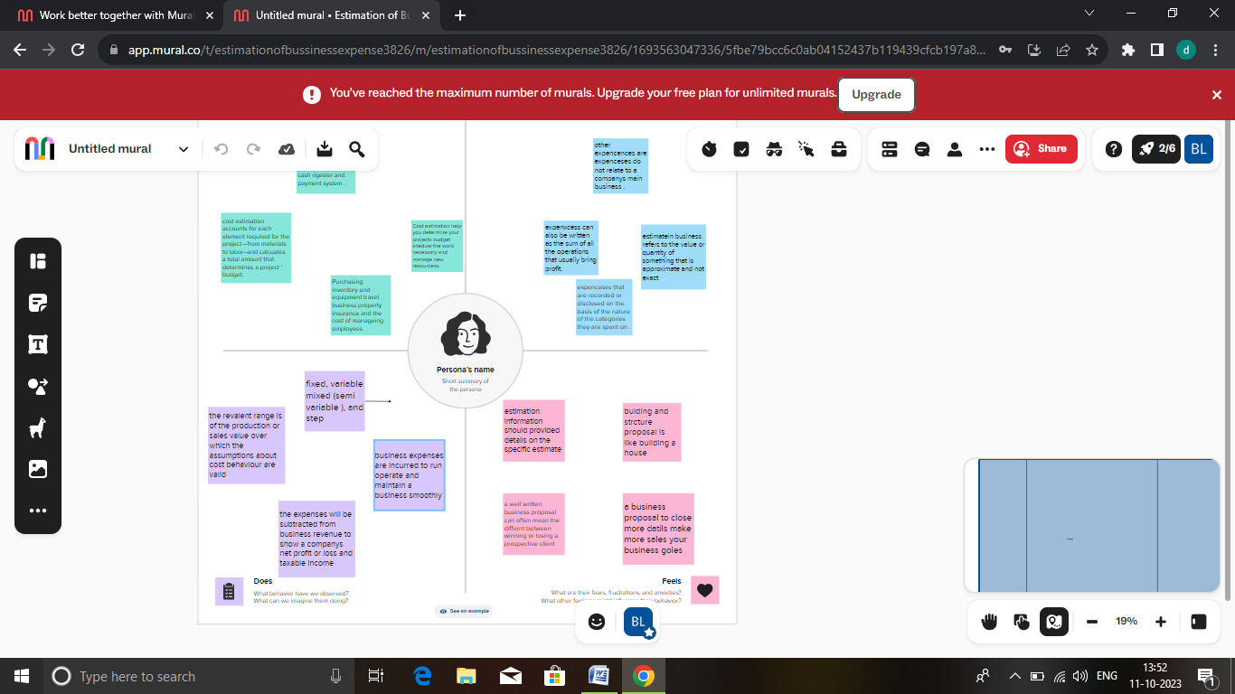

2.2 ideation & Brainstorming map

Brainstorming is a method of generating ideas and sharing knowledge to solve a particular commercial or technical problem, in which participants are encouraged to think without interruption.

Brainstorming is a creative problem-solving method that involves generating new or building on existing ideas. It can be done individually or in a group, and there are no strict guidelines for the process. To begin the process of brainstorming, it is important to first define the goal or main objective.

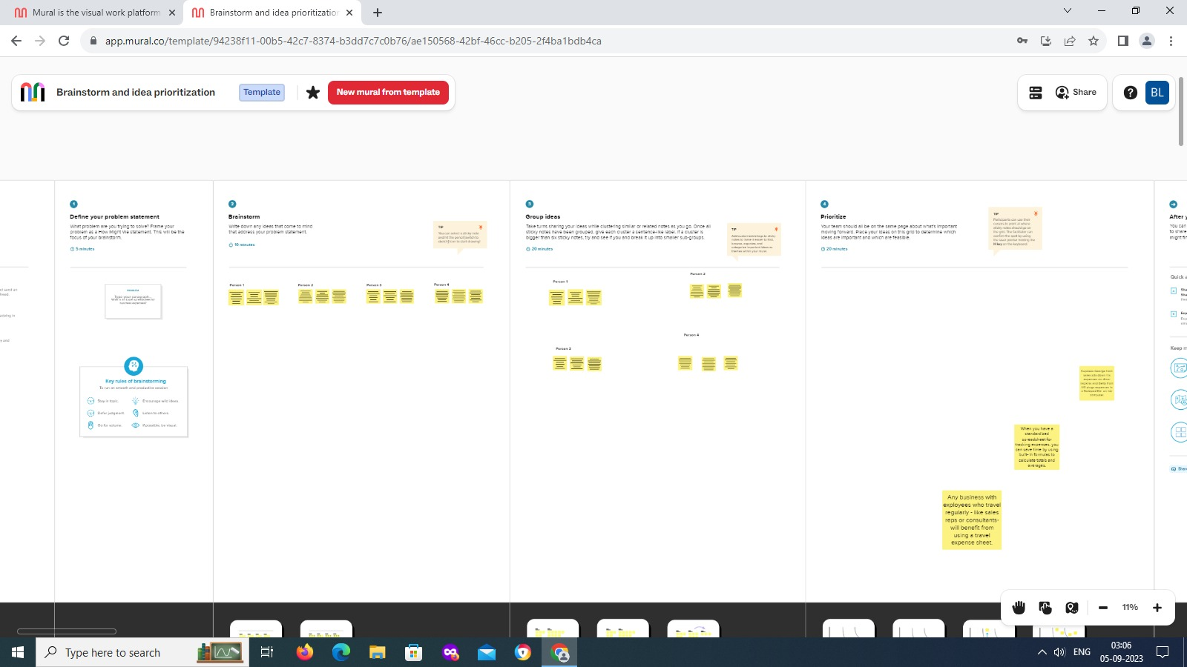

3.Result

Story I

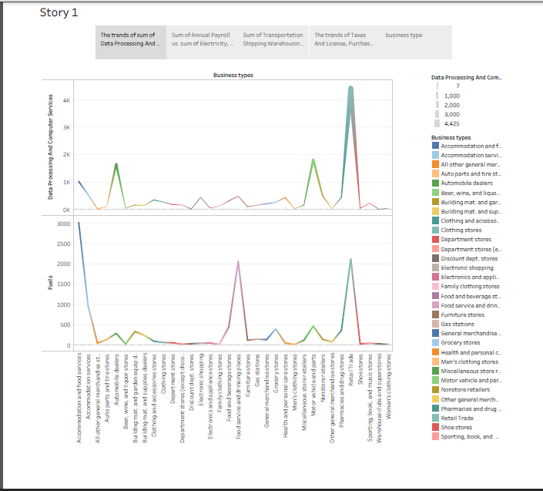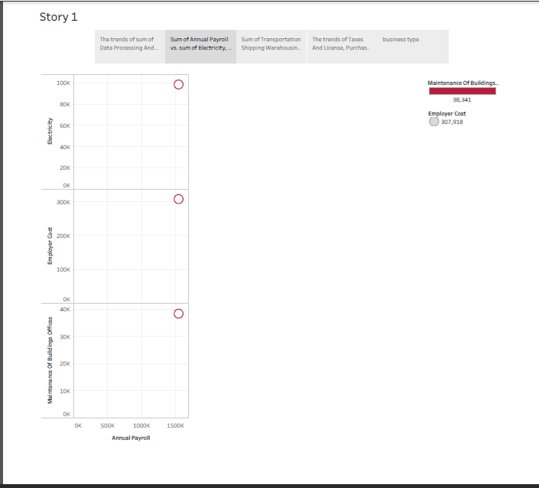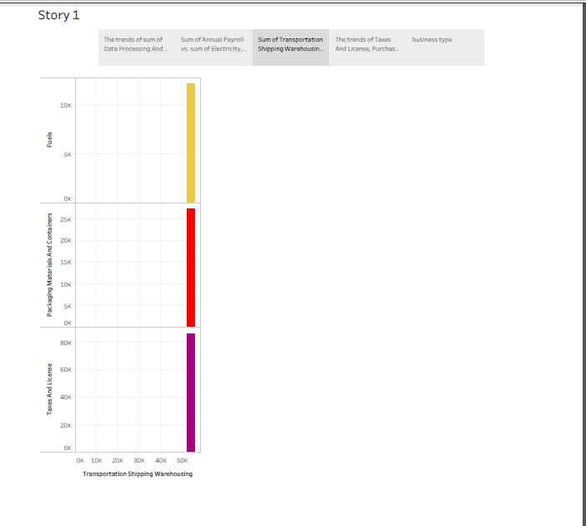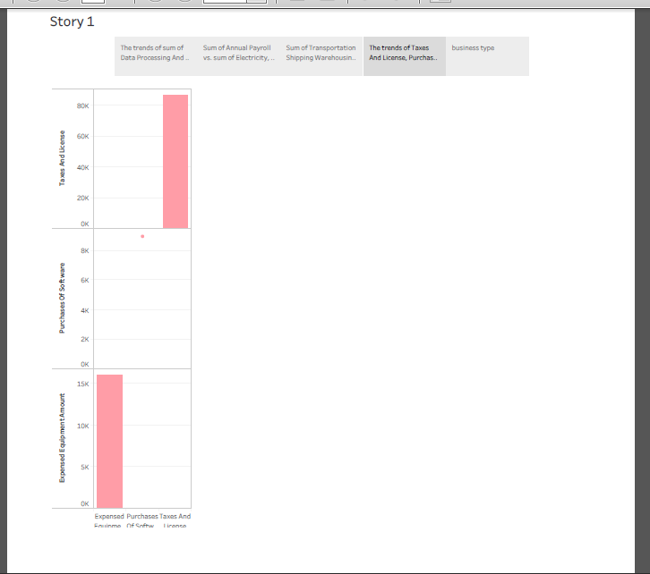

Story 2

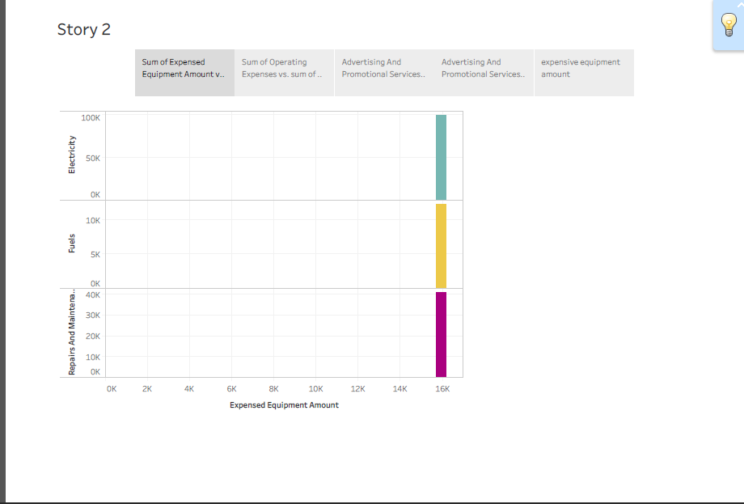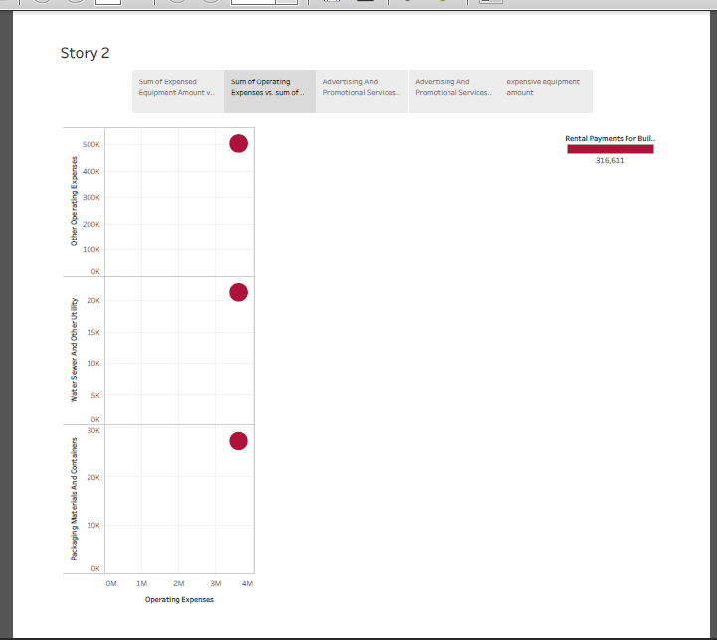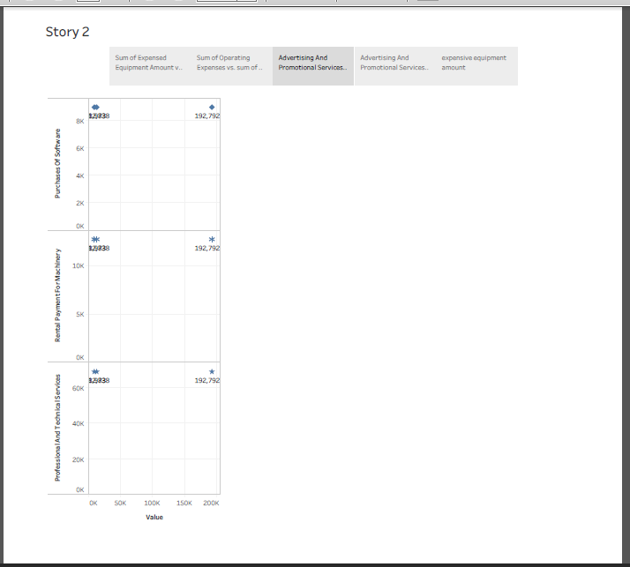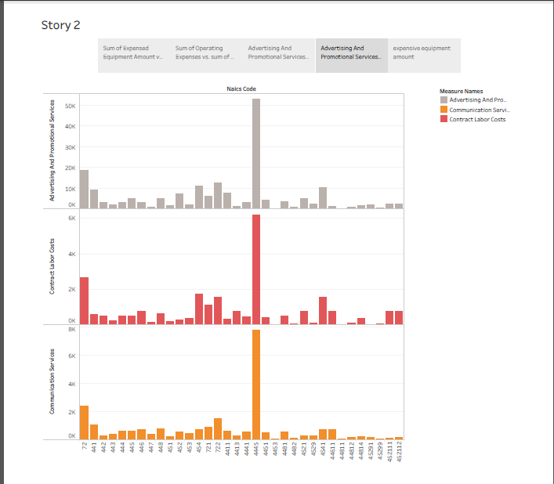

4 . Advantages & Disadvantages

* Being a business owner can be extremely rewarding. Having the courage to take a risk and start a venture is part of the American dream. Success brings with it many advantages:
* *Financial rewards*. In spite of high financial risk, running your own business gives you a chance to make more money than if you were employed by someone else. You benefit from your own hard work.
* *Learning opportunities*. As a business owner, you’ll be involved in all aspects of your business. This situation creates numerous opportunities to gain a thorough understanding of the various business functions.
* As the little boy said when he got off his first roller-coaster ride, “I like the ups but not the downs!” Here are some of the risks you run if you want to start a small business:
* *Financial risk*. The financial resources needed to start and grow a business can be extensive. You may need to commit most of your savings or even go into debt to get started. If things don’t go well, you may face substantial financial loss. In addition, there’s no guaranteed income. There might be times, especially in the first few years, when the business isn’t generating enough cash for you to live on.
* *Stress*. As a business owner, you *are* the business. There’s a bewildering array of things to worry about—competition, employees, bills, equipment breakdowns, customer problems. As the owner, you’re also responsible for the well-being of your employees.

5. Applications

A business application is a collection of components that provides a business functionality that you can use internally, externally, or with other business applications. You can create business applications of individual components, which are related to each other.

For example, Order Management, Inventory Management, and Billing are business applications that might use individual components such as a Java EE application server, LDAP, and a database that runs on the Solaris server.

Business application is a type of a custom collection. You can also create the following types of custom collections:

* Collection, which is a group of any resources that you can select according to your needs.
* Access collection, which is a collection that is used to control the access to configuration items (CIs) and permissions to modify configuration items. You can create access collections only when [data-level security](https://www.ibm.com/docs/en/SSPLFC_7.3.0/com.ibm.taddm.doc_7.3/AdminGuide/c_cmdb_sec_permission.html) is enabled.

The following methods are provided for creating business applications:

* By using grouping patterns in Data Management Portal.
* By using application descriptors.
* By using grouping patterns that are created with Java API and loaded by the bulk load program.

6.Conclusion

You’ve written your business plan, but now you want to wrap it up to make a lasting impact on your reader. In this article, we will define the conclusion to a business plan as well as provide some tips to help you attract and seal the deal with potential investors and lenders.

This business plan conclusion is a concise summary and recap of all of the [components of a business plan](https://www.growthink.com/businessplan/help-center/key-components-business-plan-part-ii), but especially the executive summary. It summarizes your business plan in 2-3 paragraphs, with an emphasis on the most important points.

The conclusion of your business plan is the last thing people read before deciding to invest in you and your business, so it needs to make a lasting impression.

7. Future scope

Business always has scope in future, only if one is serious about it and aim to prosper and not thrive. People often falter in business, because they deem it to be an easy task and look for success very early on. Just like a job, business too needs a lot of time investment and huge amount of pressure to get accustomed to. If one owns a business, then he/she must know the issues that comes with it and should therefore be prepared for the solutions too. Business can be a real good scope for future, but one needs to be very calculative in its decisions and very accurate in future prospects.

It is predicted that business that are based on collaborative economymodels will enjoy immense success in the next few years. As me good examples are Airnb, Uber, Ila and Lyft. These types of businesses not only help the final customers, but also assist theservice proiders andultimately make commission.

8. Appendix

A. Source code

https://github.com/bdu1621me1269/Estimation-of-Business-Expenses_NM2023TMID25607/upload/main